Imad Abdulelah

Module 02 Course Project - Design Your First Home Page

**Website description** – The designed website is a basic restaurant website (HTML) file. This website features a local pizza restaurant in Rockford, IL. The name of the restaurant is Rudy’s Pizza and Bakery. I used the some of the formatting to embed it on to the HTML file. The website had a logo for the restaurant, three more images for their products with additional text. A navigation banner has been created that has four options to select from, and only the ‘home’ option is currently active. The website link is: <http://imadweb.centralus.cloudapp.azure.com/web_app/project2/rudys_home.html>

GitHub URL: <https://github.com/imad-97/rasmussen-dev>

Screenshots displaying the home page:

* **On a desktop**

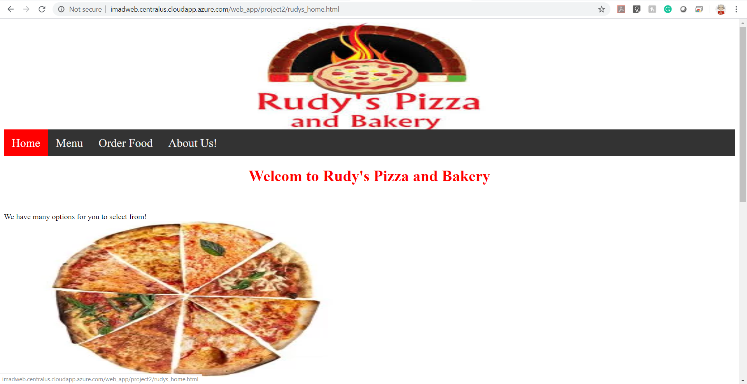

* **On a smart phone**

